# Algorithm for file updates in Python

## Project description

At my organization, access is restricted based on IP addresses within a file named “allow_list.txt”. I was provided a list of IPs to remove from the list. I created an algorithm to automate the updating process and removed the IP addresses that should no longer be on the list.

## Open the file that contains the allow list

To start the algorithm, I opened the allow list file and assigned it the variable name of import_file.

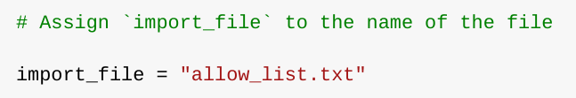

I then used a with statement to open the file.

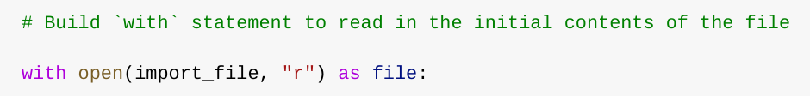

## Read the file contents

In order to read the contents of the file I used the .read() method to convert it into a string.

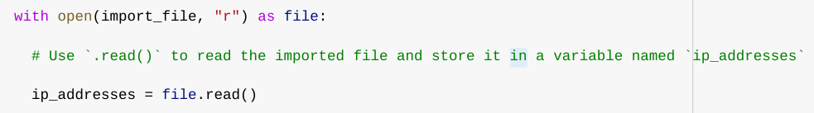

## 

## 

## Convert the string into a list

I then used the .split() method to convert the string into a list so the algorithm can remove specific addresses.

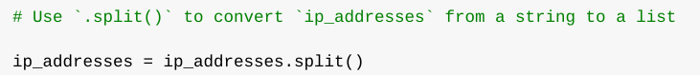

## Iterate through the remove list

An important part of the algorithm is for it to iterate through all elements in the remove_list. To do this, I created a for loop.

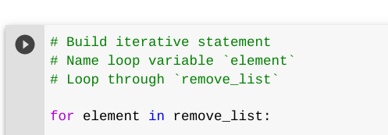

## Remove IP addresses that are on the remove list

This algorithm will remove any IP address provided in the remove_list from the allow_list.txt file.

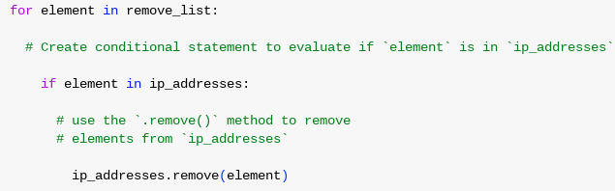

## Update the file with the revised list of IP addresses

I then needed to update the allow list file with the revised list of IP addresses. I converted the list back into a string with the .join() method.

I then used a with statement and the .write() method to update the file.

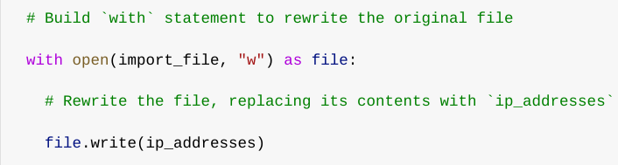

## Summary

I created an algorithm that removed ip addresses identified in a remove_list variable. This algorithm opened a file, converted it into a string, then converted the string back to a list stored in the variable ip_addresses.I then iterated through the IP addresses in remove_list and removed any from the ip_addresses variable that matched for removal. I then used the .join() method to make the list back into a string so it can be placed back in the text file “allow_list.txt”.